Real world uses to use NoSQL Database in Industry

NoSQL for Retail

Retail applications using NoSQL databases benefit from their ability to manage large, complex datasets involving customer transactions, inventory, and personalized recommendations. Their scalability allows handling high-throughput environments with spikes in activity, typical during sales events or new product launches.

Additionally, the adaptable data model supports dynamic inventory management and personalized marketing, essential for modern retail strategies that focus on customer experience and operational efficiency. This capability ensures retailers can rapidly adjust to market trends and customer preferences.

**Primary needs:** flexible product schemas, high read throughput, personalization, shopping-cart sessions, promotions.  
  
Implementing a document-oriented database like MongoDB or Couchbase can significantly enhance e-commerce platforms and product catalogs. These solutions allow for greater flexibility in handling complex product information such as varying attributes, prices, and categories.

* **Scalability:** Document stores can efficiently scale horizontally, accommodating millions of products and numerous user queries without performance degradation.
* **Dynamic Schema:** Changes to product specifications can be managed without downtime, as the database’s schema can adjust to new attributes or categories.
* **Advanced Query Capabilities:** Utilizing aggregation frameworks, businesses can perform real-time analytics to track inventory movements, sales patterns, and customer preferences.

Statistics indicate that 81% of e-commerce sites struggle with performance issues related to their databases during peak traffic times. By utilizing a NoSQL-oriented approach, companies can significantly reduce page load times and ensure a seamless shopping experience. In fact, performance optimizations lead to a 27% increase in conversion rates on average.

1. **Product Recommendations:** Implement machine learning models that integrate directly with the database to provide personalized suggestions, boosting average order value.
2. **Multi-Channel Sales:** Seamless integration with various sales channels, from websites to mobile apps, reinforces a cohesive customer experience.

The analytical capabilities supported by NoSQL databases empower retailers to analyze traffic data and consumer behavior effectively. As a result, businesses can rapidly adjust marketing strategies to target high-interest products or manage stock levels accurately.

Additionally, consider the benefits of integrating a financial advisor app for managing inventory costs and sales analytics. With real-time insights into financial performance, businesses can optimize profits while minimizing overhead.

NoSQL for Banking

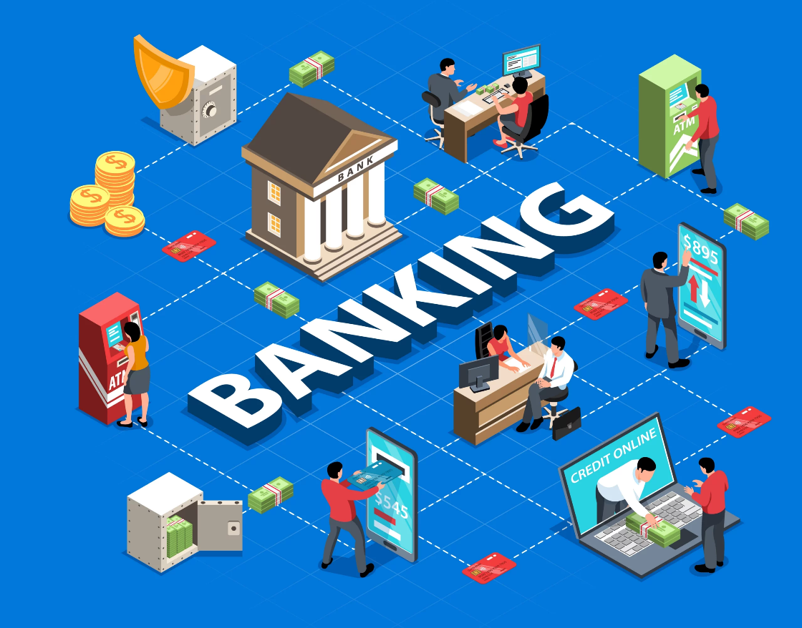

Banks handle **massive volumes of transactions** per second, plus unstructured data like KYC documents, emails, and logs.  
• Traditional relational databases struggle with scale, flexibility, and real-time analytics required for fraud detection or customer personalization.  
  
**Typical NoSQL use cases in banking:**  
1. **Fraud Detection (Graph DBs):**  
• Graph databases map relationships between accounts, devices, and transactions.  
• Helps detect suspicious loops or unusual fund transfers across accounts.  
2. **Customer 360 / KYC (Document DBs):**  
• Customer data comes from multiple sources (ID proofs, scanned documents, addresses, emails).  
• A document database can store all of this flexibly without forcing rigid schemas.  
3. **Real-time Risk & Transactions (Column-family DBs):**  
• Used to store and analyze high-frequency transaction streams.  
• Enables instant credit scoring, limit checks, and compliance monitoring.  
4. **Regulatory Reporting:**  
• Time-stamped immutable event storage supports audit and compliance requirements.

In banking, NoSQL databases are increasingly used to handle massive volumes of transactional data, customer records, and fraud detection systems. Financial institutions require high-speed data ingestion and real-time querying capabilities to monitor suspicious activities and ensure compliance. NoSQL solutions like Redis and MongoDB are ideal for storing diverse customer data, including transaction histories, credit scores, and behavioral patterns. Capital One, for instance, uses MongoDB to power customer-facing applications that require flexible data models and rapid access. Additionally, NoSQL databases support mobile banking apps by enabling fast, scalable access to user data and transaction logs, while also facilitating real-time alerts and risk analysis.

NoSQL for Social media

Social media platforms rely heavily on NoSQL databases to manage vast amounts of user-generated content, including posts, comments, likes, and messages. These platforms require low-latency, high-throughput systems to deliver real-time experiences to millions of users. NoSQL databases like Cassandra, Redis, and HBase are commonly used to store and retrieve data quickly, ensuring smooth user interactions. For example, Facebook uses Cassandra to power its messaging system and inbox search, while Instagram uses Redis for caching and Cassandra for feed generation. These databases support distributed architectures, allowing social media companies to scale globally and deliver personalized content based on user behaviour and preferences.

**Typical NoSQL use cases in social media:**  
1. **User Profiles (Document DBs):**  
• Profiles have flexible fields (bio, interests, images, settings).  
• Document DBs allow schema flexibility and easy updates.  
2. **News Feeds & Posts (Column-family DBs):**  
• Posts are time-series data (new content constantly added).  
• Column-family DBs like Cassandra efficiently handle sequential writes and high-volume reads.  
3. **Messaging & Chat (Key-Value Stores):**  
• Messages must be retrieved in milliseconds.  
• Key-value stores ensure low-latency storage and retrieval.  
4. **Recommendations & Friend Suggestions (Graph DBs):**  
• Graph databases analyse social connections to suggest friends, groups, or content.

Major social media platforms rely on NoSQL databases for real-time data processing, accommodating vast, complex interactions and connections. These databases provide the necessary performance for quick data fetching and updating, crucial for delivering seamless user experiences and fast-paced interactions.

Their support for graph data models helps manage extensive, interconnected user and content relationships, essential for delivering features like friend suggestions or content recommendations. NoSQL’s ability to adjust to ever-growing and diversifying datasets empowers social media platforms to innovate continually.

NoSQL for Education

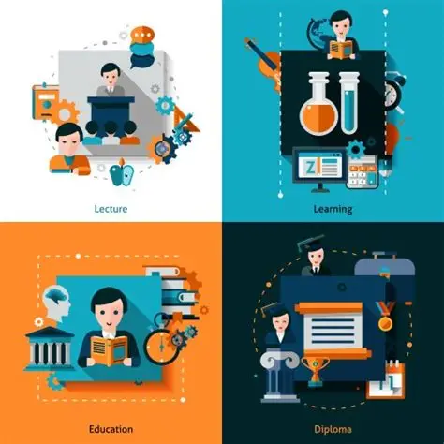

In the education industry, especially in online learning platforms, NoSQL databases play a crucial role in managing student profiles, course content, and learning analytics. Educational data is often semi-structured—ranging from text and video content to quiz results and forum discussions—which makes NoSQL a natural fit. Platforms like Coursera use MongoDB to store course metadata, user progress, and personalized learning paths. The flexibility of NoSQL allows EdTech companies to rapidly iterate on features, such as adaptive learning modules or real-time feedback systems. Moreover, Firebase (a NoSQL solution by Google) is widely used for real-time collaboration tools, enabling students and teachers to interact seamlessly across devices.

Education platforms manage **diverse content types** (videos, quizzes, notes) and **personalized learning paths** for each student. Relational models are too rigid for adaptive learning needs.  
  
**Typical NoSQL use cases in education:**  
1. **Learning Content Storage (Document DBs):**  
• Courses contain structured (quizzes) + unstructured (videos, PDFs) material.  
• Document DBs can handle flexible and multimedia-rich content.  
2. **Student Progress Tracking (Column-family DBs):**  
• Every click, quiz attempt, or video watch event is logged as time-series data.  
• Column-family DBs can store this activity efficiently for analysis.  
3. **Adaptive Learning & Recommendations (Graph DBs):**  
• Graph DBs map relationships between concepts, courses, and student skills.  
• Used to recommend the next best learning activity for a student.  
4. **Collaboration & Social Learning:**  
• Social-like features (discussion forums, peer connections) can use graph databases to connect learners.